ZOLTAN SZTRELCSIK

Budapest/Hungary

szzoltan@gmx.net

zoltan@gmx.net

# **Documentation for Sales Tax Calculator WPF application**

This user-friendly application is able to calculate and output the sales tax calculation for different products. It contains 3 sample baskets, and it can calculate new product baskets as well. You enter the amount, name and net price for each product, and the solution calculates gross price for each item, as well as the total sales taxes and total price. In addition, you can send the results into a .txt file or into a .pdf file.

Extra features:

* you do not need to type in the content of any sample basket – just click on the corresponding button and the basket content will be displayed immediately; of course the user may choose to type in the content of any basket, or change it
* you can change any shopping basket and generate the results for them
* the changes are stored in memory, you can reuse the changed baskets
* this applies also for the new basket
* you can any time reset the baskets and use their original content
* the application calculates the total price for any product if you provide an amount of more than 1; therefore, the price should always be indicated for 1 unit
* you can add a huge amount of products into a basket, and you can scroll through them in both the input and output boxes

Input and output screen for sample shopping basket 1:

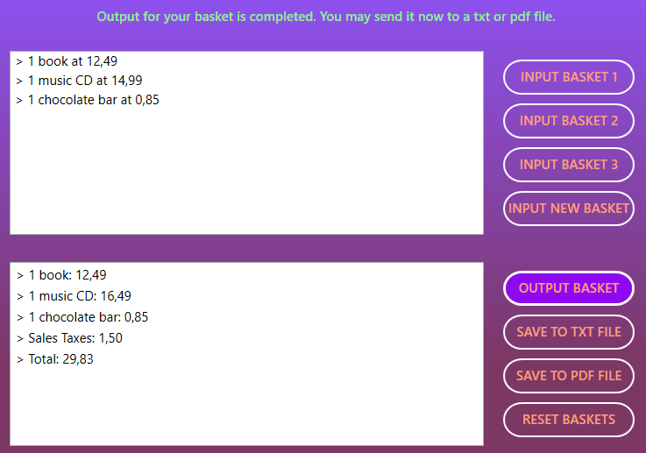

Input and output screen for sample shopping basket 2:

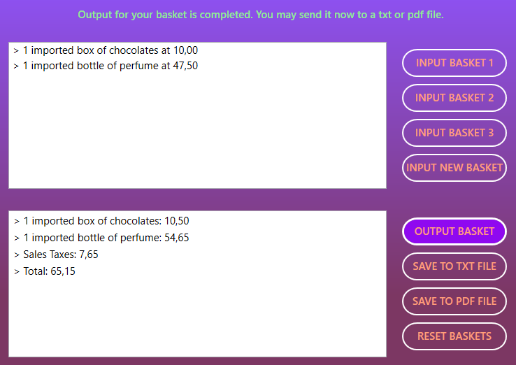

Input and output screen for sample shopping basket 3:

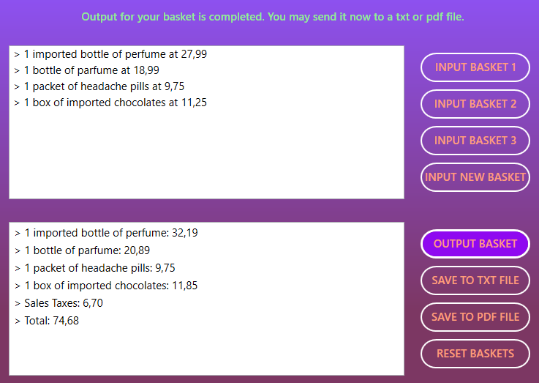

Input and output screen for new shopping basket with product in various amounts:

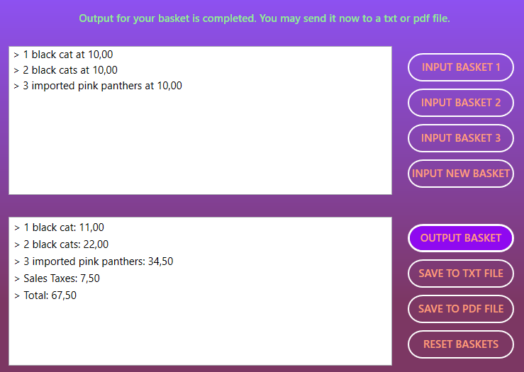

Please note that according to the regional settings of the user, the decimal symbol can be ‘.’ or ‘,’, so the output may contain different decimal symbols. It does not impact the calculation.

Assumptions

In the challenge task, the input shopping basket 3 contains a product with name ‘box of imported chocolates’, but in the output this name changed to ‘imported box of chocolates’. I assumed that it is consequent to leaves the name of this product unchanged. I also assumed that a useful feature could be to calculate the total price also for items with an amount greater than 1.

There is no need for you to build the application as I created setup files for it. Simply use any of the two setup files and with a few clicks the installation will be complete and you can start the application with a shortcut from your Windows desktop. The github link of the project is this: <https://github.com/sztrelcsikzoltan/WPFSalesTaxCalculator>. The installation files are here: <https://github.com/sztrelcsikzoltan/WPFSalesTaxCalculator/tree/main/Installation%20files>

The products meets the requirements of the challenge description. Of course, the application can be improved in many ways (adding further products for existing categories, adding new tax rate categories, storing shopping baskets, products and categories in files or database, etc.)

Best Regards,

Zoltan Sztrelcsik